***HTML Notes***



**HTML (HyperText Markup Language)** is the standard language used to create webpages. It defines the **structure** and **content** of a webpage using **tags**.

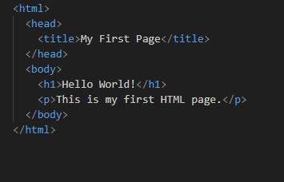

**<html>**  **-** Root element of the HTML page

**<head> -** Contains metadata, title, and linked files

**<body> -** Contains visible page content

**<title>** - Sets the title in the browser tab

**1.Text Formatting Tags**

|  |  |  |
| --- | --- | --- |
| *Tag* | *Description* | *Example* |
| <h1>–<h6> | Headings | <h1>Heading</h1> |
| <p> | Paragraph | <p>This is text.</p> |
| <b> / <strong> | Bold / Important text | <strong>Important</strong> |
| <i> | Italic | <i> Italic </i> |
| <u> | Underline | <u>Underlined</u> |
| <br> | Line break | — |
| <hr> | Horizontal line | — |

**2.Lists**

**Ordered list**

<ol>

<li>First</li>

<li>Second</li>

</ol>

**Unordered list**

<ul>

<li>Apple</li>

<li>Banana</li>

</ul>

**Definition List**

<dl>

<dt>HTML</dt>

<dd>HyperText Markup Language</dd>

</dl>

3. Links and Images

**link**

<a href="https://example.com"> Visit </a>

**href → URL**

**image**

<img src="image.jpg" alt="Description" width="300" height="200">

src → Image path

alt → Alternate text

width, height → Dimensions

**4. Table**

<table border="1">

<tr>

<th>Name</th>

<th>Age</th>

</tr>

<tr>

<td>John</td>

<td>25</td>

</tr>

</table>

| **Tag** | **Description** |
| --- | --- |
| <table> | Table container |
| <tr> | Table row |
| <th> | Table header |
| <td> | Table data cell |
|  |  |
|  |  |

**5. form**

An **HTML form** is used to **collect user input** and send it to a server for processing.  
The form elements are inside the <form> tag.

<form action="submit.php" method="post">

<label for="name">Name:</label>

<input type="text" id="name" name="name">

<input type="submit" value="Submit">

</form>

* **file upload**

<input type="file" name="resume" >

Requires enctype="multipart/form-data" in the <form> tag.

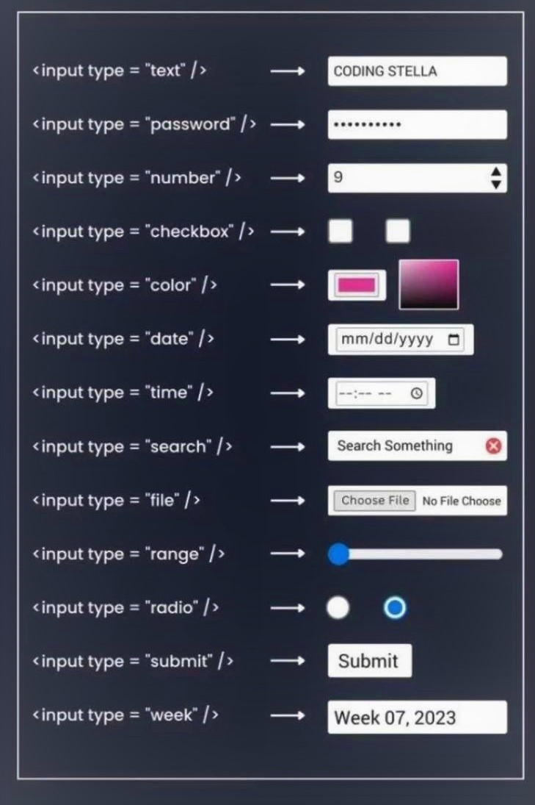

**6. Other Useful Tags**

|  |  |
| --- | --- |
| Tag | Description |
| <div> | Generic block container |
| <span> | Inline container |
| <iframe> | Embeds another webpage |
| <link> | Link to external files (like CSS) |
| <script> | For JavaScript code |

7. Multimedia

<video controls width="400">

<source src="video.mp4" type="video/mp4">

</video>

<audio controls>

<source src="sound.mp3" type="audio/mpeg">

</audio>